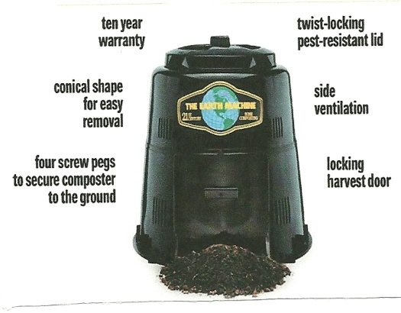
Composting Workshop
Come learn about backyard composting, a great way to reduce waste and create compost--a great resource for landscapes and gardens. The Earth Machine™ composter will be available for purchase.
Saturday, April 10th
10:30 a.m.
Garabrant Center, 4 Wilson Street, Mendham
Come learn how to start your own compost pile from New Jersey composting and gardening educator Virginia Lamb. Green waste from your yard and kitchen accounts for approximately 25% of the material being hauled from your home each week. By composting, you can improve your soil for healthier, more productive lawns and gardens, while reducing waste at the same time.
To purchase your Earth Machine, it must be pre-ordered by Friday, March 26th. The purchase price of $55.00 includes the composter and the kitchen scrap bucket. The workshop is free.
To register for the free workshop and/or to pre-order the Earth Machine composter fill out the below form and mail it to: Mendham Borough, 2 West Main St., Mendham, NJ 07945. Checks should be made payable to: Mendham Borough and in the memo write: composter
Name: ___________________________________________________________
Address: _________________________________________________________
Phone # ______________________ E-Mail _____________________________
____ Workshop Only ____Composter Only ____Workshop and Composter
Contact: Laurie Felber 973-543-0663 or email lorraine.felber@gmail.com

