Sept. 21, 2017
Official News Release
For Immediate Release

MORRIS FREEHOLDERS TO MEET IN MENDHAM BOROUGH ON WEDNESDAY EVENING
HANOVER MT. ARLINGTON ALSO ON REMAINING 2017 SCHEDULE

The Morris County Board of Freeholders will hold their next meeting on Wednesday evening, Sept. 27, in Mendham Borough as part of the board’s eight-stop 2017 ”road meeting’’schedule.

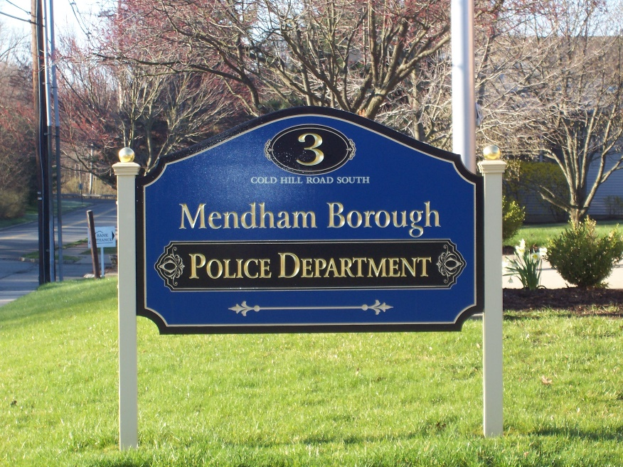
This would be the couty governing board’s first meeting in the borough since Sept. 16, 2011.

The freeholders hope the meeting makes it more convenient for borough residents to attend. They also are inviting residents of nearby towns, including the Chesters, Mendham Township, and Washington Township, to attend the meeting, ask questions about county issues, and to learn more about their county government.

Moving freeholder board meetings out of the county seat in Morristown to the county’s 39 municipalities is part of the board’s continuing effort to bring county government closer to their constituents.

The county government road meetings for the rest of 2017, all to be held in town halls or community centers and starting at 7 p.m., include:

- Sept. 27, Mendham Borough, Garabrant Center, 4 Wilson St, Mendham N.J. 07945
- Oct. 25, Hanover Township, 1000 Route 10, Whippany, N.J. 07981
- Nov. 20, Mount Arlington, 419 Howard Blvd., Mount Arlington, N.J. 07856

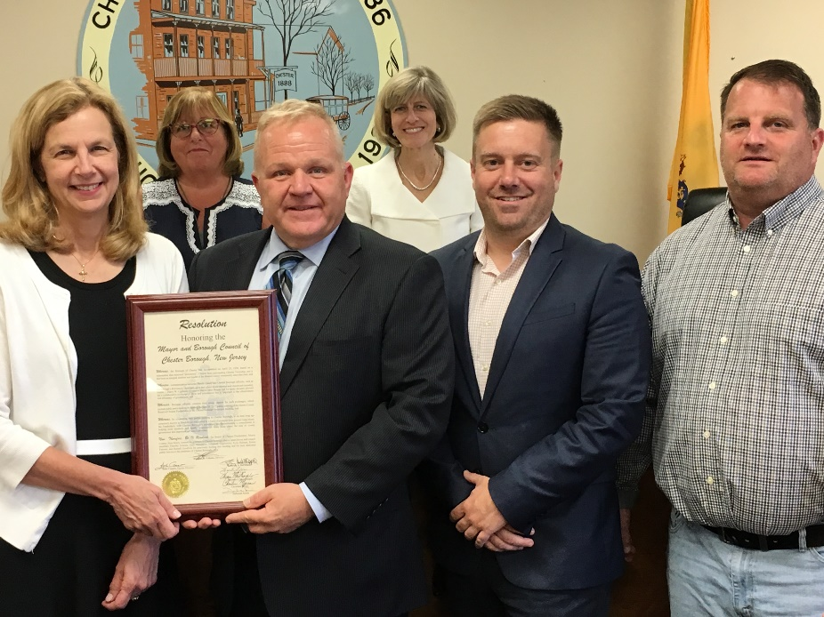
The Freeholders voted earlier this year to continue their tradition of holding some county government meetings away from the county government headquarters in Morristown. So far this year, the board has met in Chester Borough, Morris Plains, East Hanover, Kinnelon, and Victory Gardens.
Freeholder Director Doug Cabana presents resolution to Chester Mayor Janet Hoven at a June 28 road meeting in Chester Borough

“It is important to meet county residents where they live and work, and to make it more convenient for residents and elected officials to have access to county government,’’ said Freeholder Director Doug Cabana.

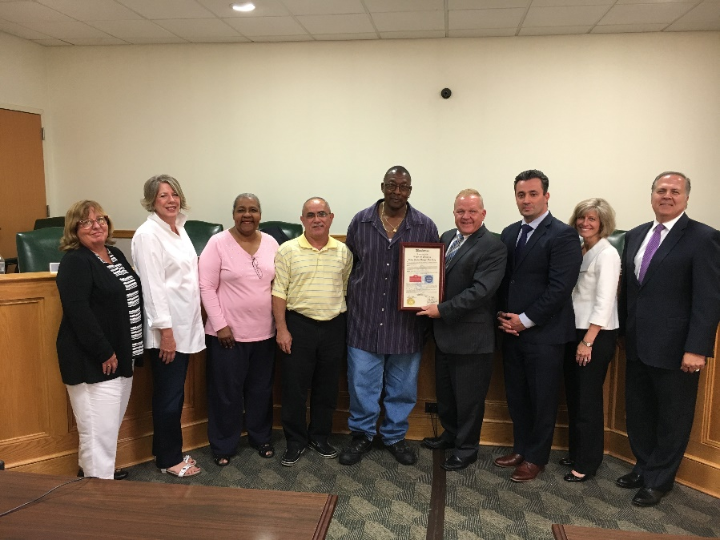
“Road meetings give local residents and officials an opportunity to raise regional issues of concern to the freeholders, so we can better understand and focus on them,’’ said Deputy Freeholder Director John Cesaro.

The board of freeholders meet twice monthly, usually on the evening of the second and fourth Wednesday of each month in Morristown. The public can comment at those meetings.
Freeholders with Victory Gardens Mayor David Holeman and Council at the board’s Aug. 23 freeholder meeting in Victory Gardens

The board also holds public work sessions on the mornings of the second and fourth Wednesdays in Morristown. Residents are invited to observe but cannot comment at work sessions.

Mendham Borough was incorporated as a borough by an Act of the New Jersey Legislature on May 15, 1906, It is located 40 miles west of New York City.

Known for its rich historic charm and quaintness, Mendham Borough is home to noted landmarks such as the Phoenix House, which serves as the Borough's Municipal Building and the Black Horse Inn. Mendham Borough's population is 5,097.
Agendas for Freeholder meetings are posted at https://morriscountynj.gov/freeholders/publicmeetings-about/

For more information on Mendham Borough, visit: http://www.mendhamnj.org/
or https://www.facebook.com/Mendham-Borough-Historical-Society-201946593204843/

For more on county government, visit: https://morriscountynj.gov/

####

