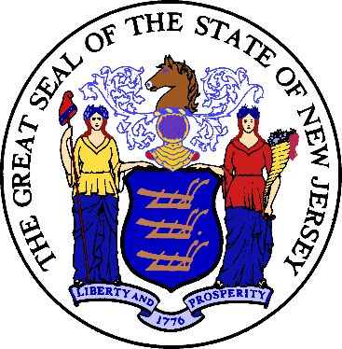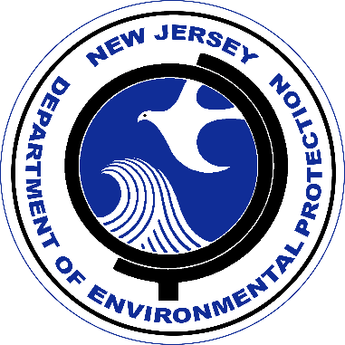

Construction of upgrades and improvements to Mendham Borough WRF, 35 Ironia Rd. Mendham, NJ at a cost of $1,775,250 were financed by the New Jersey Water Bank (NJWB). The NJWB is a State Revolving Fund program jointly administered by the New Jersey Department of Environmental Protection (DEP) and the New Jersey Infrastructure Bank (NJIB) and uses a combination of funds provided by the United States Environmental Protection Agency, the DEP, and the NJIB to provide very low interest loans to borrowers for environmental infrastructure projects.

This project will provide water quality benefits by reducing infiltration of ground water to the system, therefore, improving both the hydraulic loading and efficiency of the treatment plant for residents and businesses within the Mendham Boro Sanitary Sewer Collection System, Mendham Borough, NJ.

State Revolving Fund programs around the nation provide states and communities the resources necessary to maintain and improve the infrastructure protecting our valuable water resources nationwide.

