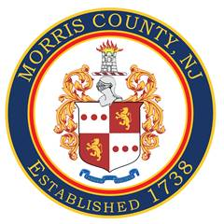
COUNTY OF MORRIS
Office of Communications & Digital Media

PRESS RELEASE:
July 2, 2025
For Immediate Release

Morris County Sheriff’s Office Issues Fireworks Safety Tips
Celebrate Safely This Fourth of July
Happy 4th of July! Sheriff James M. Gannon and the Morris County Sheriff’s Office remind everyone to celebrate responsibly this Independence Day by following safety guidelines when handling fireworks.
Fireworks Safety Tips:
- Never use fireworks while impaired by drugs or alcohol.
- Always supervise children, especially when using sparklers.
- Use sparklers with extreme caution – they burn at very high temperatures and can cause serious injuries.
Legal Consumer Fireworks:
- Ground-based sparkling devices
- Smoke bombs
- Handheld sparklers
Illegal Consumer Fireworks Include:
- Firecrackers
- Aerial rockets
- Any device that explodes or launches into the air
Commercial Grade Fireworks:
- Are for professional use only
- Contain multiple explosive charges
- Should never be handled by the public
- Can cause serious injury or death
If You Encounter an Unexploded Firework:
- Do not assume it is a “dud”
- Isolate the area and notify the fireworks display manager
- If found outside of a professional event, contact the Morris County Sheriff’s Office Bomb Squad immediately
Know the Law:
- New Jersey Law: Consumer fireworks must comply with state regulations
- Federal Law: Governed by the Bureau of Alcohol, Tobacco, Firearms and Explosives (ATF)
The Morris County Sheriff’s Office Bomb Squad is available 24/7 to provide technical assistance in the event of a fireworks-related incident. To report suspicious items or for more information, contact the Morris County Communications Center at 973-285-2900.
###

