

**YOGA in**

**THE PARK**

**June 28, 2022**

Scheduled Teacher: Nathalie Masse

[Book Class](https://www.fortheloveyoga.com/bookings-checkout/free-yoga-in-the-park/book)

**July 12, 2022**

Scheduled Teacher: Melissa Wojcik

[Book Class](https://www.fortheloveyoga.com/bookings-checkout/free-yoga-in-the-park/book)

**July 19, 2022**

Scheduled Teacher: TBD

[Book Class](https://www.fortheloveyoga.com/bookings-checkout/free-yoga-in-the-park/book)

**July 26, 2022**

Scheduled Teacher: TBD

[Book Class](https://www.fortheloveyoga.com/bookings-checkout/free-yoga-in-the-park/book)

**Yoga Instructors and Borough Residents Nathalie Masse, Melissa Wojcik and Dana Leigh Nix have offered to teach free Yoga classes for Borough Residents**.

**Tuesday Evenings at 6:30pm**

**August 2, 2022**

Scheduled Teacher: TBD

[Book Class](https://www.fortheloveyoga.com/bookings-checkout/free-yoga-in-the-park/book)

**August 9, 2022**

Scheduled Teacher: Dana Leigh Nix

[Book Class](https://www.fortheloveyoga.com/bookings-checkout/free-yoga-in-the-park/book)

**August 16, 2022**

Scheduled Teacher: TBD

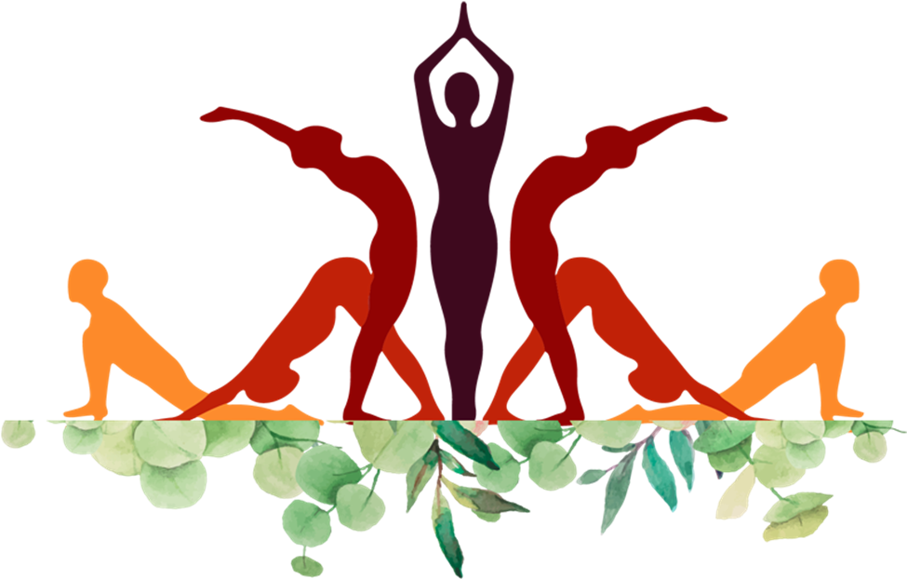

**Location:**

Small field at the far end of Borough Park.

The easiest way to access it is from the Municipal Parking Lot behind Windswept and Robinson’s on Main Street

**Please register at:**

[**https://www.fortheloveyoga.com/free-yoga-in-the-park-is-back**](https://www.fortheloveyoga.com/free-yoga-in-the-park-is-back)

***No Experience Needed, All Levels Welcomed!***

**Bring your yoga mat, beach towel or props and come unwind!**