ECOSST
2022-2023
Cary (Scott) Barn & Farm Planning Document

Barn and Outbuildings
- Proposal and grant approved by Borough to Morris County Historic Preservation Commission for the barn's architectural/stabilization plans. Plans Completed.
- Submit in 2023 for Grant to restore Barn as Bird Watching Pavilion, meeting, and picnic area.
- Restore Out buildings.
- Work with Audubon Society, Rutgers’s co-op extension, etc., to help set up programs and keep them updated with our progress.

The trail To and Around the Property
- Increase the number of people who use the trail.
- Install "Cary (Scott) Farm" town signs and Kiosks at Barn Parking lot and Patriot Path/Pastime Field.
- Install Park benches around the Pastures loop.

Open Field
- The Open Field will be broken into 1/3's with each section to be a different Open Space initiative.
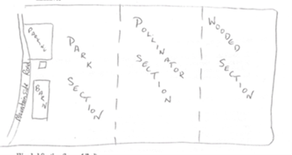
Wooded Section (lower 1/3rd)
- Reforest lower 1/3rd with NJ native species of Trees. Doing this will cut down on maintenance and help absorb wet terrain.
- Remove all evasive bushes from the Field.
- The Path will continue to be maintained as the trees grow.
Pollinator Section (middle 1/3rd)
- GSA Troop 97604 Pollinator Project “Aire Bee-N-Bee” to be implemented in 2023.
- Planting of pollinators tree/plants to foster the habitat for the insect and animal populations in Mendham borough.
- Construction of bird/ bat houses and other dwellings. Possible BSA Eagle Scout Project.
- Plant "Whipstock" around the stream bed.
- Plant native species and remove evasive plants.
Park Section (upper 1/3rd)
- Park area ad seats and picnic tables.
- Old farming equipment removed.

