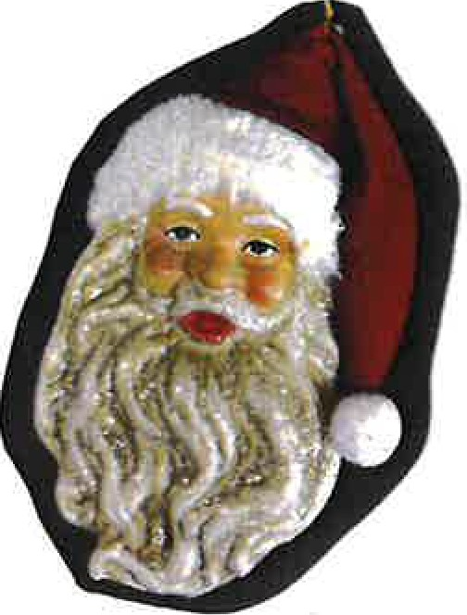
Where's Santa Contest
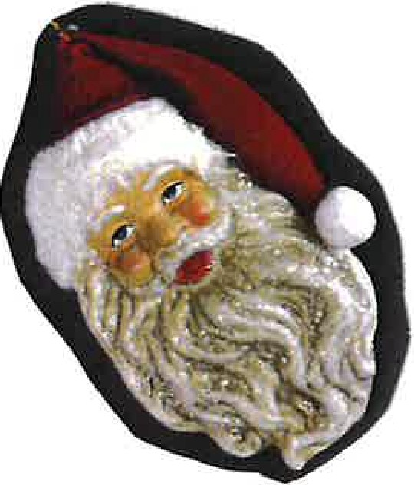
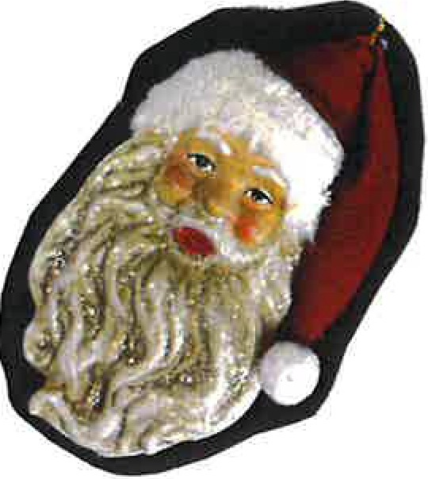
Visit the businesses listed below, find Santa, have the business initial your paper, Bring the form to Mendham Jewelers with your name and phone number on it.

Dantes ___
Mendham Jewelers ___
Mendham Garden Center ___
Peapack-Gladstone Bank ___
UPS Store ___
Chapter One ___
Mendham Bagel ___
Hand in Hand Chiropractic ___

Wicker Basket ___
Mendham First Aid Squad___
Angela London Hair Studio ___
St. Marks Church ___

Maji Hair Salon ___
JA Morey Artisan Chocolate ___
Peggnet Computers ___
Olivera Hair ___
Sapori D'ltalia ___
Coldwell Banker ___
Provident Bank ___
Phoenix House ___
Simple Coffee ___
Mendham Borough Library ___
Black Horse Pub ___
Weichert ___
Grace Lutheran Church ___
Mendham Mathnasium ___
Luminous By Lucia ___
Mendham Creamery ___
Mendham United Methodist Church ___

Contest ends Dec. 14th

Bring form to Mendham Jewelers to enter to win a gift card.

